Curate and Create Your Own Art Museum

Student’s Name
Institutional Affiliation
Course Name and Number
Instructor’s Name
Assignment Due Date

Introduction
Name as well as the location of the Museum and your initial response.
I visited the first online Museum in the city of San Francisco. Since I have constantly been astounded by the Asian works of art and their culture, I felt the impression of having viewed the arts available in the Museum.
My next Museum is indeed the Museum of Art in Philadelphia. The second one I toured. Museum, I was delighted. The reason is that the Museum has an extensive collection of artworks from all over the world.
The 3rd Museum I've toured is the New York Metropolitan Art Museum. I was thrilled to go to the Museum because it is one of the museums with many old Greek artifacts, and I was constantly impressed by Greek artifacts as an art fan.
Sculpture or Painting
1st Sculpture or Painting
- Piece name, the culture from which it comes from, & piece description:
The initial sculpture is from the sitting Buddha, which dates back to 338. The statue was discovered in Northern China, it has not been painted in dark blue, but it was encrusted with gold (Gellert, 2018). Currently, the work of art is in San Francisco's Asian Art Museum.
- My first response (impressed, happy, and puzzled)
When I viewed the work, and more so, I was amazed when I learned more about it. One of the most astonishing facts is that it was almost perfectly preserved of the oldest Buddhist objects.

- I chose this painting because of the reason.
I chose this artwork because it was present during the first time the Chinese people became Buddhists. Invaders known as Jie-Indians invaded northern China around the year 310, bringing Buddhism.
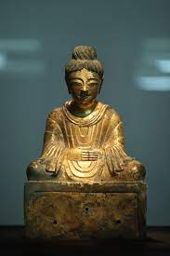
2nd Sculpture or Painting
- Piece name, the culture from which it originates, & Piece description:
The 2nd sculpture is classified in the Philadelphia Museum of Art as Indra, Lord of Storms, and King of the Gods' Realm c 1200. It belongs more particularly to the Indonesian people of Asia. The sculpture consists of three eyes, a gorgeous garment, a magnificent crown, and other gems. The sculpture is located. However, one knee is lifted, and it is regarded as a royal facility (Strømmen, 2020). The thumping and index fingertip are squeezed together; it's a learning sign and symbol.
- My first response (happy, puzzled, and impressed)
When I viewed the first piece, I was impressed. The details of the artists were so impressive in the sculpture. A lot of thinking has become a masterpiece in the work of art.
- I chose this part because of the reason.
I picked this work of art because it reveals those various religions and faiths, such as the B0uddhists, Hindus, and Jains, venerated the item.
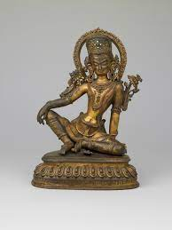
3rd Sculpture or Painting
- Piece name, the culture from which it originates, & Piece description:
The 3rd pillar, with the female figure under a tree c 100 – 200, is called the railing pillar. It comes from the culture of India. The sculpture is a bulky figure and vivid, brownish vine. This work of art is located in the Museum of Asian Art.
- My first response (happy, puzzled, and impressed)
I was intrigued when I saw this sculpture because it was distinguished from other works I saw. It is not simple to recognize how the sculpture is constructed from what area of the world it comes from.

- I chose this part because of the reason.
This sculpture is the reason I chose because of its symbolization. According to Indian beliefs, the female's sculpture signifies fertility because a female in her childhood can make a tree flower bloom. The women are prominently synonymous with fecundity in the hips and breasts of the sculpture.
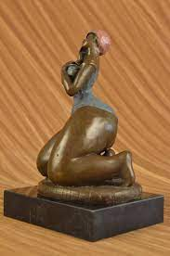
4th Sculpture or Painting
- Piece name, culture from, & piece description:
The fourth piece of artwork at the Museum of Metropolitan Arts is a Terracotta pelike (jar) from about 440 to 450 Before Christ. The work of art comes from Greek cultural identity (Heuer, 2019). It's just an old jar in gold-designed hue black.

- My first response (happy, puzzled, and impressed)
When I saw this work of art, I was impressed. It's striking because, albeit more than one thousand years of age, it appears perfect. Also impressive is the art in the jar that tells a tale.
- That is the reason I have chosen this piece.
It also comes from the majority of jars gathered since it is still very much intact and vivid. I picked the piece because I love old Greek objects.
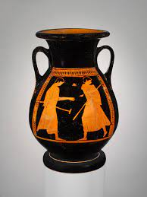
5th Sculpture or Painting
- Piece name, the culture from which it originates, & Piece description:
Approx. In the 5th century, the fifth piece was known as the terracotta prefix (tooth tile). The piece of art belongs to Greek culture. It is housed at the Municipal Museum of Arts (Miller, 2021). It's a Medusa sculpture, a female with hairs and canine tooth surface.

- My original response (happy, puzzled, and impressed)
When I was first found this sculpture, I was amazed since it still shows several features; for instance, the hair is clear, and its face is white, and since the iris is projecting, it is obvious it is painted.
- I chose this painting because of the reason.
I chose this piece of art because the Greek myth of Medusa always captivated me. Since I was a little child, I have heard stories of Medusa, and that work of art shows the history and how the antique Greek images of Medusa are known.
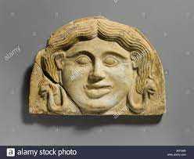
Conclusion
I would make sure that I gather and present artworks from every region of the world if I could be a museum founder and curator. It will make people appreciate the beauty of the Arts and embrace and appreciate many civilizations. As a creator and founder, one makes things that were forgotten for a long time to be relevant again. The most successful work. It's interesting and will capture many individuals; I will share the project outdoors.

References
Gellert, C. A. (2018). From the Earthly to the Celestial: Material Culture and Funerary Practice at Japan's Sixth-Century Fujinoki Kofun (Doctoral dissertation, University of California, Berkeley).
Strømmen-Bakhtiar, A. (2020). Introduction to Digital Transformation: and its impact on society. Informing Science Press.
Heuer, K. (2019, June). Tenacious Tendrils: Replicating Nature in South Italian Vase Painting. In Arts (Vol. 8, No. 2, p. 71). Multidisciplinary Digital Publishing Institute.
Miller, T. K. (2021). Arts-Led Gentrification and the Curated Image of Contemporary Mediterranean Cities: Destruction and (Re) Construction in Marseille and Tel Aviv (Doctoral dissertation, The University of Arizona).

